freETarget
Application Note: Browser Operation

INTRODUCTION
The FreeETarget CP client is intended as the primary interface to the FreeETarget target. The client supports a wide variety of targets, operating modes, and settings. The target does support a browser-based interface but with a very limited panel. This document describes the browser interface

OVERVIEW
The browser interface on FreeETarget is designed as a complement to the existing PC Client. Once the client has setup the parameters such as LED brightness, the browser client can start and stop a shooting session and observe the shots. It must be pointed out that the browser is a very simple interface with very limited controls
Ports and Services
The browser uses two ports and several services on each port. Table 1, lists out the services on each port.
Port | Service | Description
80 | /help | Help screen with command listings
80 | /who | Short status message that describes the operation of the target
80 | /json | Emulation of the built in command processor ex, {“ECHO”:0}
80 |  | Target display (default)
Port | Service | Description
8080 | /menu | Session control menu
8080 | /help | Duplicate of port 80 help
8080 |  | Menu (default)

USING THE BROWSER
Viewing the Shooting Session
To observe the target session, enter the IP address of the target and hit enter. The target will be displayed. If there are any shots pending they will be transmitted to the display. This is illustrated in Figure 1.

Controlling the Shooting Session
Once a session has been started, it is controlled by accessing the menu on port 8080. Enter the IP address of the target as shown in the example 192.168.10.9:8080/menu. The menu will be shown as in Figure 2.
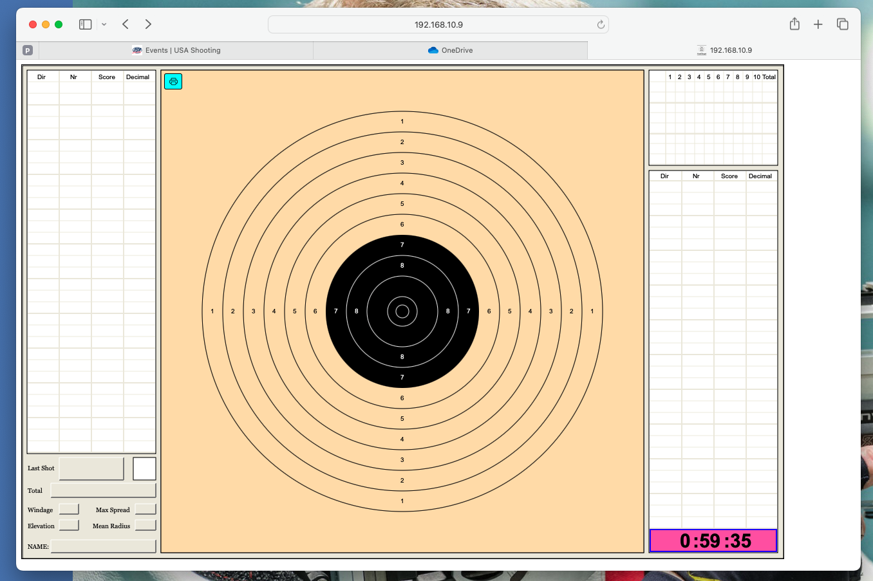
Figure 1: Target Session

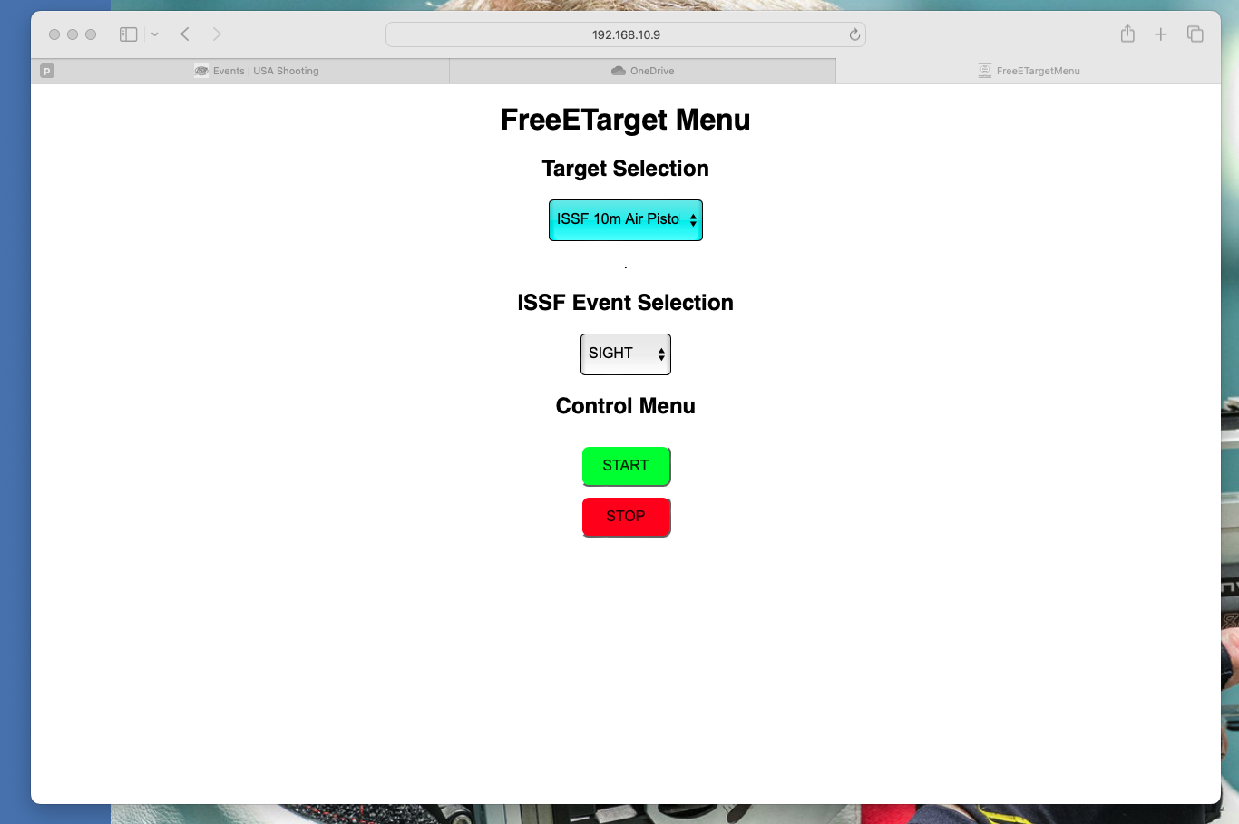
Figure 2: Target Session Control

Select the target type and event. When ready, press START to begin shooting. When finished press STOP. The session will automatically stop after fifteen minutes of inactivity.

ACCESSING THE TARGET BY NAME
If you know the target’s name, you can access the target directly. In Figure 3, the browser accessed the target by the name fet-target.local. You can find the target’s name by using the who service as illustrated in Figure 4. In this case FET-TARGET

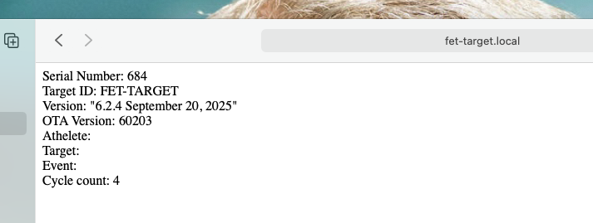
Figure 3: Accessing the Target by Name

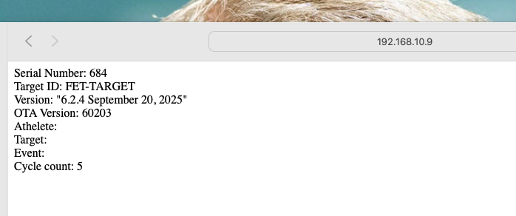
Figure 4: Finding the Target Name by IP address.

